Assignment 9
Git Branching

1. Observe the HEAD pointer

Commands executed
Command: git log --oneline

Observed output and explanation
The git log --oneline command displays the commit history in a compact format. Each commit is identified by a unique abbreviated hash and a commit message. HEAD indicates the currently checked-out commit or branch. The git log --oneline command displayed five commits in the repository.The HEAD pointer is currently pointing to commit 3fd7bf3, with the message removed readme, on the master branch.

Terminal screenshot
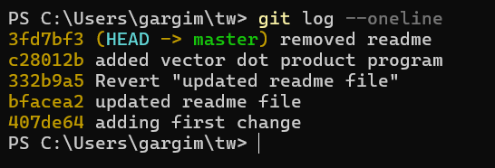

2. Create the fast branch

Commands executed
Commands: git branch fast; git branch
Observed output and explanation
The git branch fast command successfully created a new branch named fast. The git branch command displayed all available local branches. The asterisk (*) indicated that master was still the active branch.

Terminal screenshot
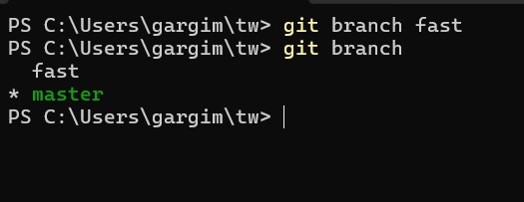

3. Rename fast to parallel

Commands executed
Command: git branch -m fast parallel , git branch

Observed output and explanation
The git branch -m fast parallel command renamed the existing fast branch to parallel. The branch listing confirmed that parallel exists and master remains the active branch.

Terminal screenshot
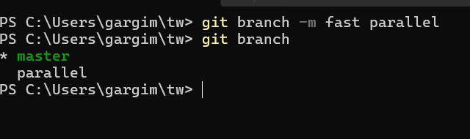

4. Switch to parallel

Commands executed
Commands: git checkout parallel; git status

Observed output and explanation
The git checkout parallel command successfully switched the active branch from master to parallel. The git status command confirmed that the current branch is parallel and the working directory is clean.

Terminal screenshot
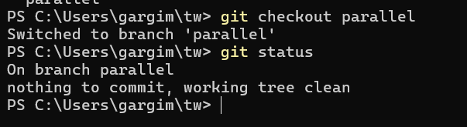

5. Modify and commit the parallel implementation

Commands executed
Commands: edit vecadd.py; git add vecadd.py; git commit -m "..."; git log

Observed output and explanation
: The sequential implementation was modified using Python's ProcessPoolExecutor. The vector pairs were divided into smaller chunks, and multiple worker processes calculated partial dot products. The partial results were combined to obtain the final dot product.
The program was tested with two vectors, [1, 2, 3, 4] and [5, 4, 3, 4]. The output was 38.
The changes were committed on the parallel branch with commit hash 3a2984e. The Git log showed that the master branch remained at its previous commit, while parallel contained the new implementation.

Terminal screenshot
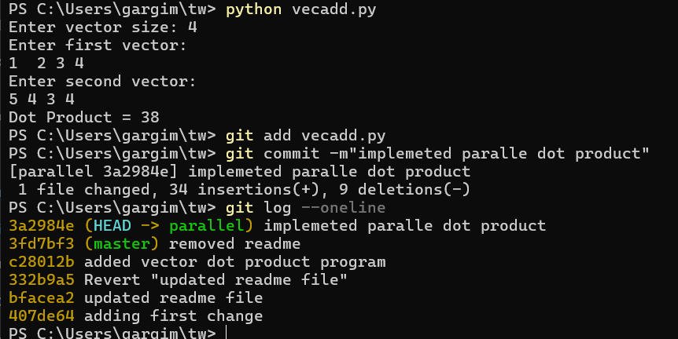

6. Fix a bug on main/master

Commands executed
Commands: git checkout main (or master); edit vecadd.py; git add vecadd.py; git commit -m "..."; git log --oneline --all --graph; git status

Observed output and explanation
The original sequential implementation was modified on the master branch by adding vector-size validation. This prevents errors when the entered vector lengths do not match the specified size.
The changes were committed successfully with commit hash 554ab7a. The git status command confirmed that the working directory was clean.
The parallel branch retains its separate implementation and commit history.

Terminal screenshot
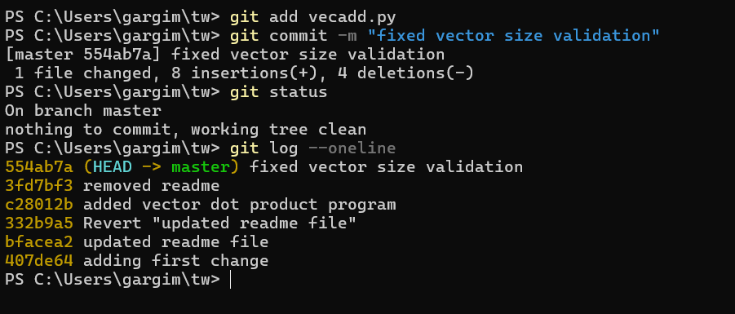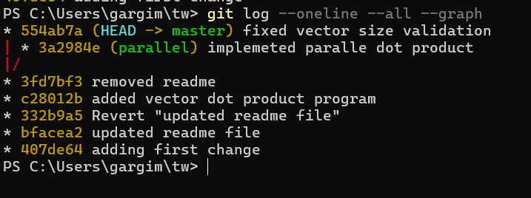

7. Merge parallel into main/master

Commands executed
Commands: git checkout main (or master); git merge parallel

Observed output and explanation
The merge operation started on the master branch. Git attempted to automatically merge vecadd.py but detected a content conflict because the same file had been modified independently in both branches.

Terminal screenshot
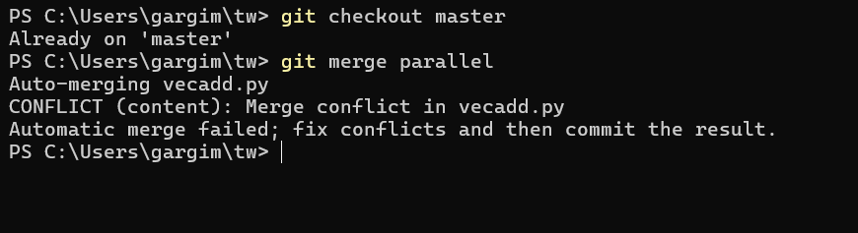

8. Resolve a merge conflict if required

Commands executed
Commands: inspect/edit vecadd.py; remove conflict markers; git add vecadd.py; git commit

Observed output and explanation
Git detected that vecadd.py had been modified in both branches. The conflicting sections were manually combined by retaining the parallel implementation and vector-size validation. All conflict markers were removed.
The resolved file was staged using git add vecadd.py and committed successfully with commit hash 27498bc. The final status confirmed that the working directory was clean.

Terminal screenshot
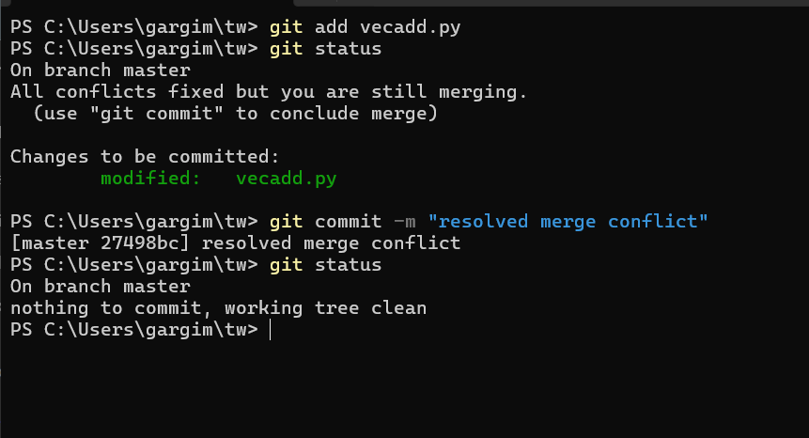

9. Delete the parallel branch

Commands executed
Command: git branch -d parallel

Observed output and explanation
After successfully merging the parallel branch into master, the parallel branch was no longer required. The git branch -d parallel command deleted the merged branch. The final branch listing confirmed that only master remained.

Terminal screenshot
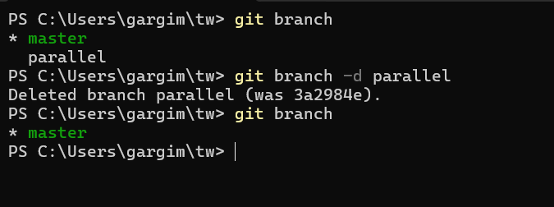

10. Explore git stash

Commands executed
Commands: git help stash; make a temporary tracked-file change; git stash; git stash list; git stash pop

Observed output and explanation
Initially, git status showed that vecadd.py had uncommitted modifications. The git stash command temporarily saved the changes. The git stash list command displayed the saved stash entry. The git stash pop command successfully restored the changes and removed the stash entry.The final git status confirmed that vecadd.py was modified again.

Terminal screenshot
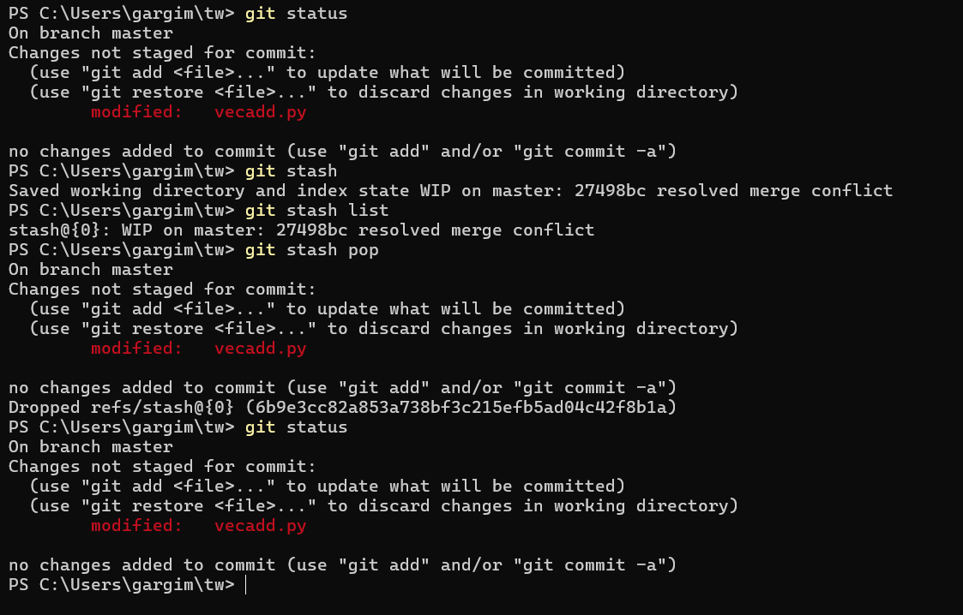

Conclusion
Through this assignment, I learned how to work with Git branches and manage different versions of a project independently. I practised creating, renaming, switching and deleting branches using Git commands. I also implemented a parallel version of the vector dot-product program using Python's ProcessPoolExecutor while keeping the original sequential implementation on the master branch.Furthermore, I learned how to make separate commits on different branches, merge branches, identify and resolve merge conflicts manually, and use git stash to temporarily save and restore uncommitted changes.Overall, this assignment helped me understand how Git branching supports parallel development, version control, collaboration and efficient project management.

